**Laravel Project Creation**

1. Install laravel using cmd
   1. **composer create-project laravel/laravel project_name**
2. Start laravel server
   1. **php artisan serve**
3. Create Auth view and controllers
   1. **php artisan make:auth**
4. Create database in mysql
5. Change database, username and password in .env file
6. Make default tables in database using cmd
   1. **php artisan migrate**
7. Change default string length in **app/Providers /AppServiceProvider.php** page like for create a new table
   1. **use Illuminate\Support\Facades\Schema;** (Add this on the top)
   2. **Schema::defaultStringLength(191);** ( Add this in boot function)
8. Create new table using cmd
   1. **php artisan make:migration create_table_name –create=table_name**
9. Make newly created table in database
   1. **php artisan migrate**
10. Make newly created table in database by this way also
    1. **php artisan migrate --path=/database/migrations/test/**
11. Disable auto login during Registration
    1. Comment line **$this->guard()->login($user);** from **vendor/laravel/framework/src/Illuminate/Foundation/Auth/** **RegistersUsers.php**
12. If you want to add more fields in **`users`** table then first add that fields on **user.php** file located in **HTTP** folder.
13. Create new model with database migrations
    1. **Php artisan make:model ModelName –m**
    2. After make a model run command **php artisan migrate**
    3. Table will create in database
14. We can create a helper in laravel
    1. **app/http/helpers/any.php ( like helper.php )**
    2. Open **composer.json** file and add code ( object ) in **autoload array on line 24**
    3. **“files” : [“app/http/helpers/any.php”]**
    4. Run command in cmd
    5. **composer dump-autoload**
    6. After create a helper we can write common functions in helper and can access by function name directly on any controller and blade view
15. We can create a **request** using cmd in laravel for **custom validation**
    1. **Php artisan make:request RequestName**
    2. Add this request file in controller on top with use and call in function replaced by **Request** in function parameters
    3. Write rules in return array in request file
    4. Change **return true** in **authorize function** in request file
    5. Get **old value** in form input and check if error is found in errors array, If error found in errors then print the errors like this –

**@if($errors->has(‘field_name’))**

**{{ $errors->first(‘field_name’’) }}**

**@endif**

1. If we want to create form in laravel style then follow the instructions :
   1. [**https://laravelcollective.com/docs/5.0/html**](https://laravelcollective.com/docs/5.0/html)

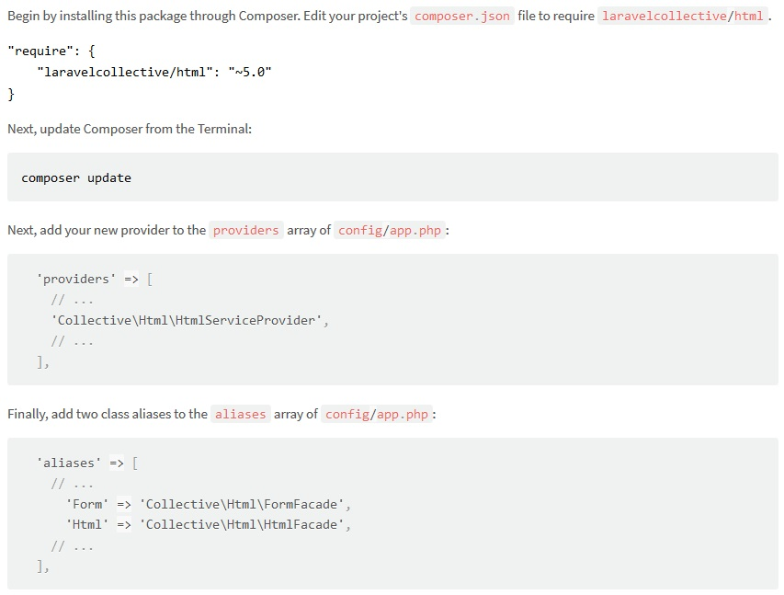

1. If you want to sent email form localhost using gmail server then follow bellow mentioned instructions
   1. Add below lines in “**vendor\swiftmailer\swiftmailer\lib\classes\Swift\Transport\StreamBuffer.php on line no 265”**
   2. **$options['ssl']['verify_peer'] = FALSE; $options['ssl']['verify_peer_name'] = FALSE;**
2. How to use model functions in laravel
   1. Create any function in model using prefix **scope** like

**Public function scopegetData() { # … code }**

* 1. Now we have to use model in controller like **use App\ModelName;**
  2. Now we can call model function in controller without scope like **ModelName::getData();**

1. If we want to print any query then we have to write this statement
   1. **dd($row->tosql())**
   2. Write a query in $row without **->get()**